2020 International Convention of Alcoholics Anonymous

July 2-5, 2020 Detroit, Michigan
The 2020 International Convention of Alcoholics Anonymous will be held July 2–5, 2020 in Detroit, Michigan with the theme “Love and Tolerance is our Code.” A.A. members and guests from around the world will celebrate A.A.’s 85th year at this event with big meetings held Friday night, Saturday night and Sunday morning in the Ford Field Stadium. Other meetings, scheduled or informal, will take place throughout the weekend in the COBO Center in downtown Detroit.
We know many are excited about the International Convention and eager for detailed information. As the time gets closer, additional information about the Convention and Detroit, our host city, will be provided.
This website will be updated as more information becomes available. Also watch for articles in Box 4-5-9 that is mailed to the general service representative of every group in the U.S. and Canada listed with G.S.O. and is also posted on the website.
Information about Convention registration and housing reservations will be available in fall 2019. All necessary information will be included in the registration packet which will also be available in the fall of 2019. This packet will list numbers to call for answers to specific questions about housing, the program, etc. The information will be mailed to A.A. groups, offices and contacts around the world and posted on the website.
We look forward to seeing you in Detroit!
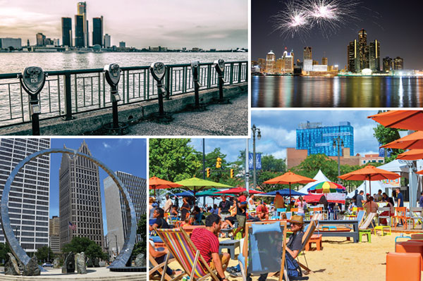

For Box 4-5-9 articles on the
2020 International Convention of Alcoholics Anonymous:
Fall 2016

